**Spring data JPA using Hibernate-3**

**Name:Akanksha Tyagi**

**id=4701**

**1. Create a class Address for Author with instance variables streetNumber, location, State.**

Address.java

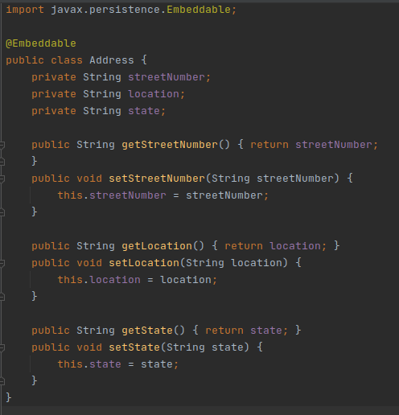

**2. Create an instance variable of the Address class inside the Author class and save it as an embedded object.**

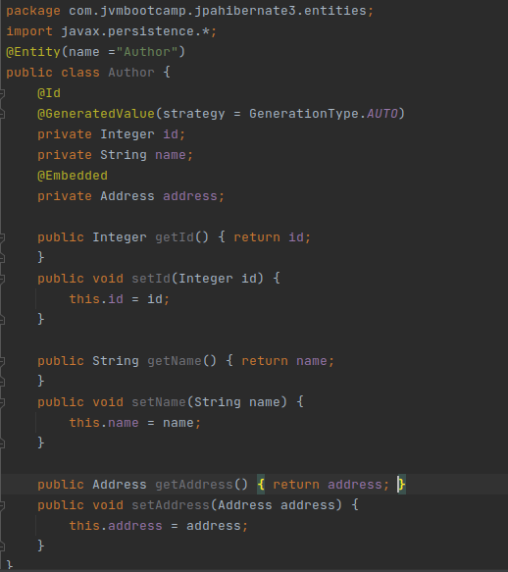



**3. Introduce a List of subjects for the author.**

Author.java

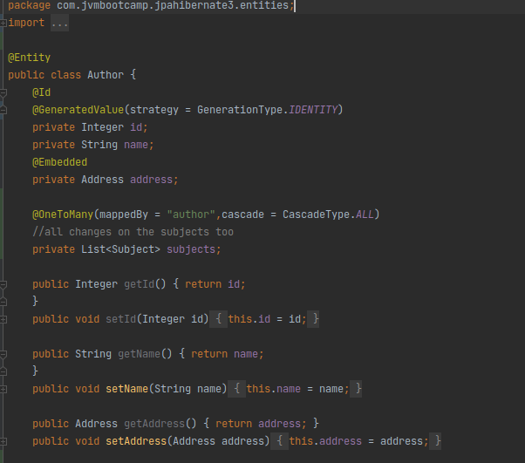



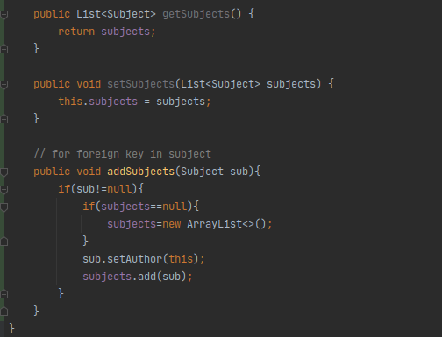

Subject.java

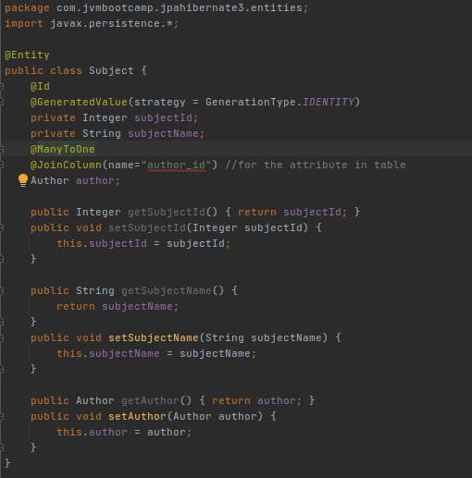



**Output :**

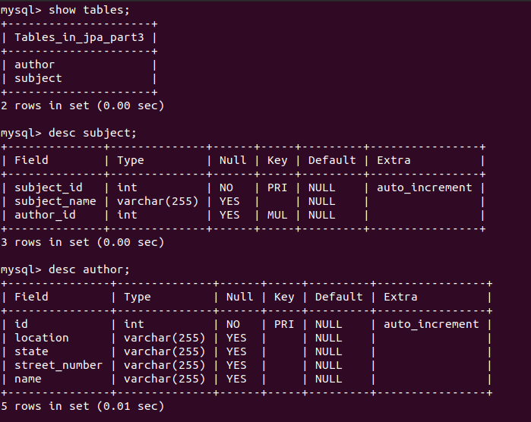

**4. Persist 3 subjects for each author.**

AuthorController.java

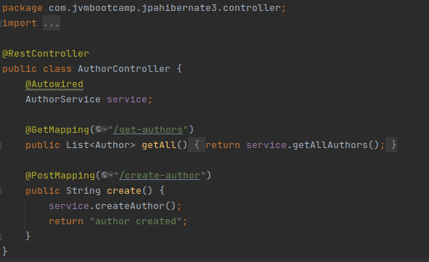

AuthorService.java

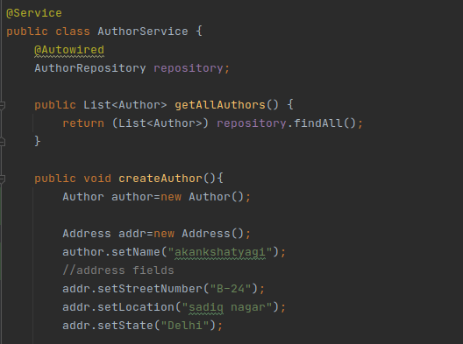

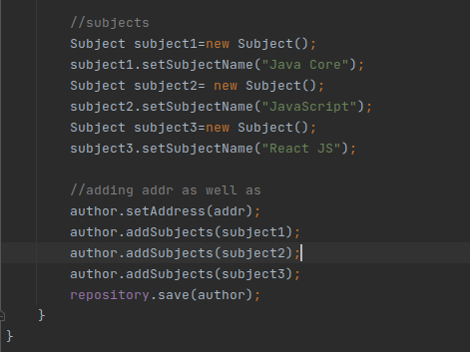

AuthorRepository.java

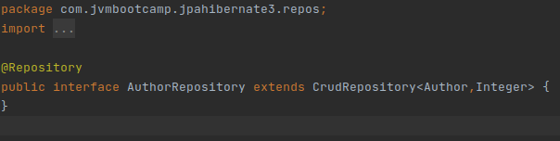

**Output:**

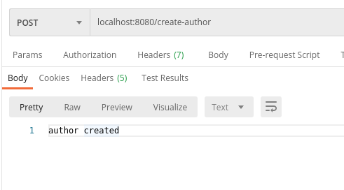

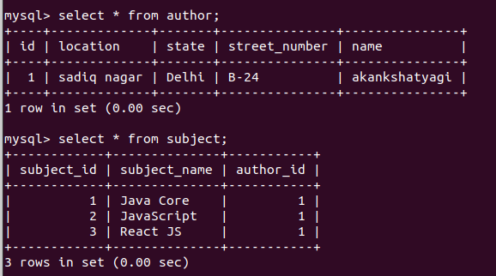

**5. Create an Entity book with an instance variable bookName.**

Book.java

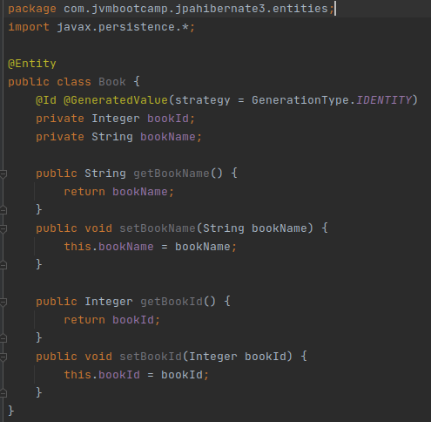

Author.java

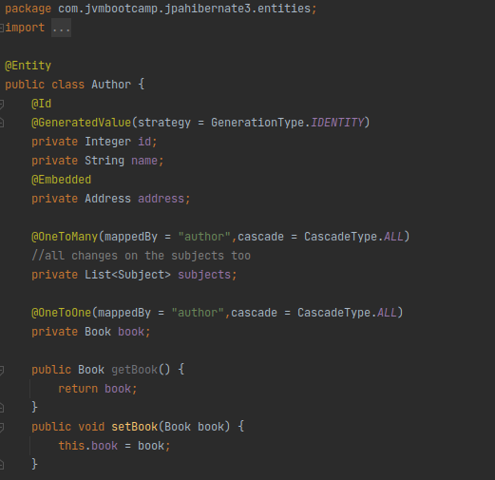

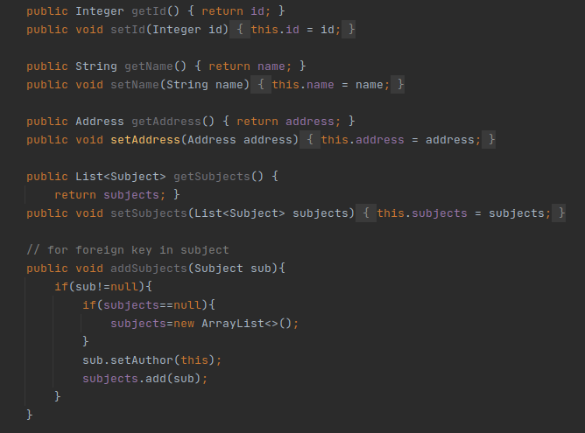

**6. Implement One to One mapping between Author and Book.**

AuthorController.java:

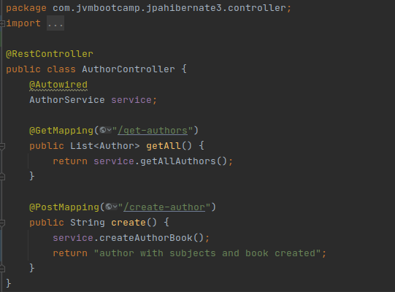

AuthorService.java:

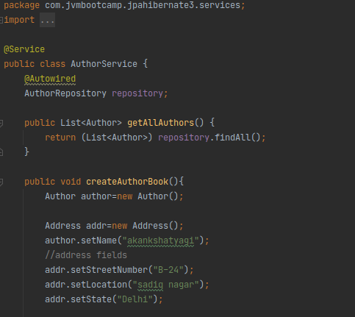

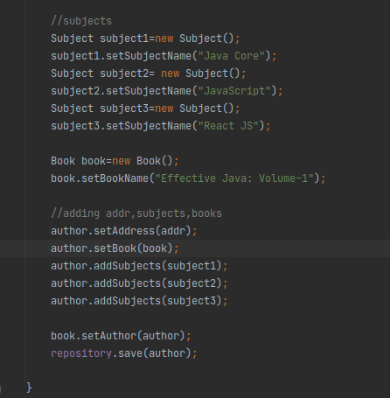

Output:

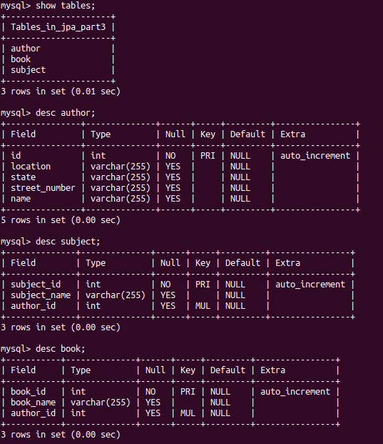



**Inserted data--**

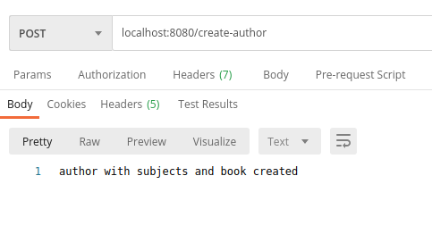

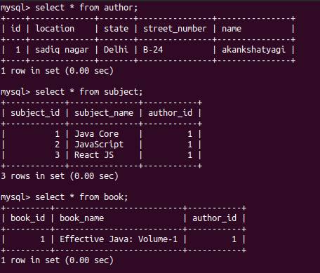

**7. Implement One to Many Mapping between Author and Book(Unidirectional, BiDirectional and without additional table ) and implement cascade save.**

**Unidirectional:**

**CODE:**

Author.java

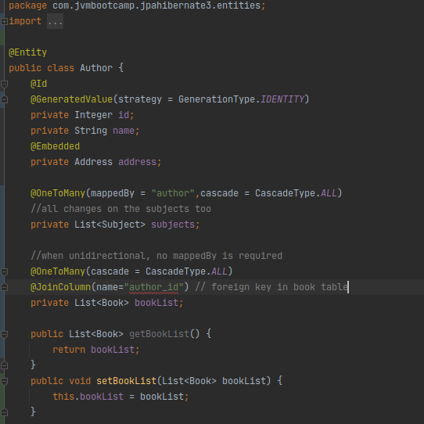

Book.java

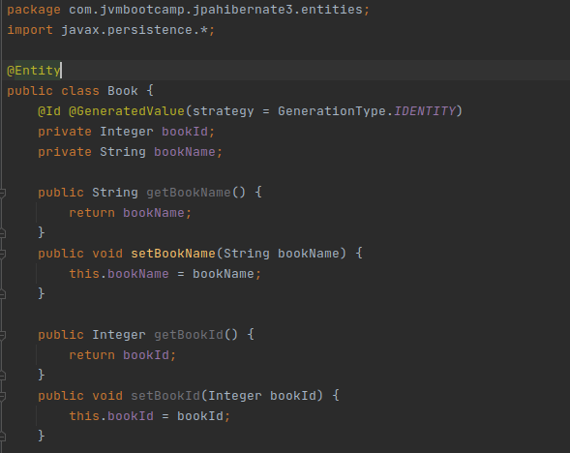

AuthorController.java

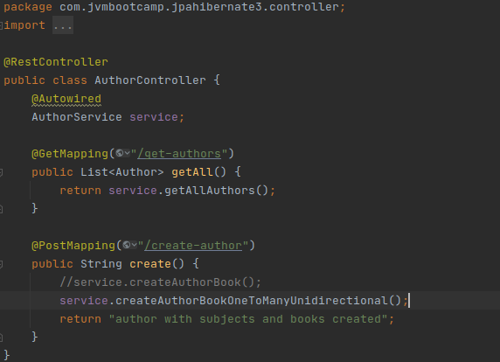

AuthorService.java:

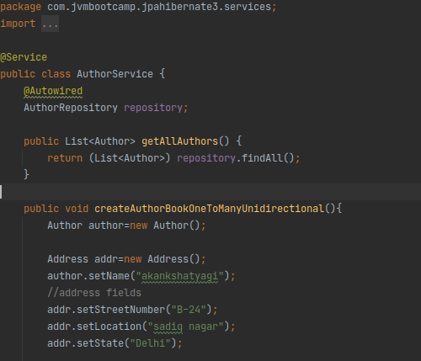

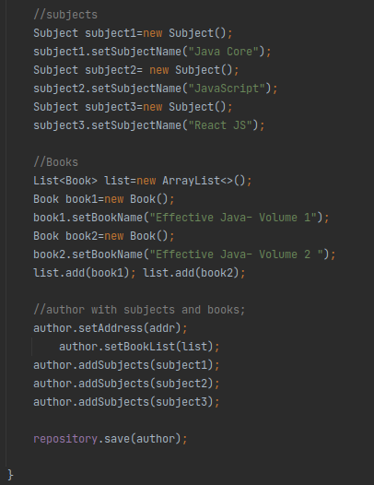

**Output:**

**Tables-**

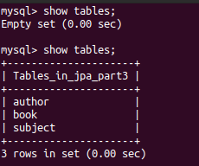

**Description:**

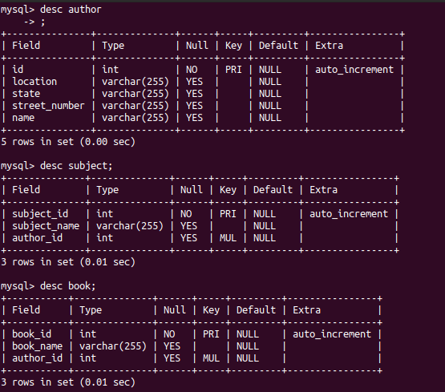

**Inserting data:**

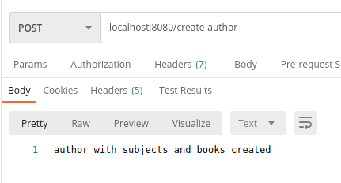

**Select * from various tables:**

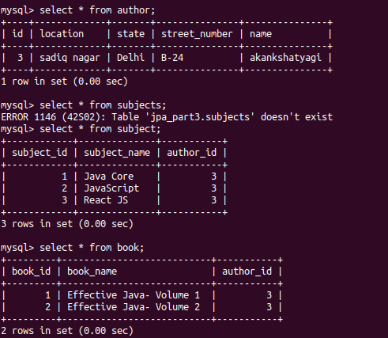

**Bidirectional:**

Author.java

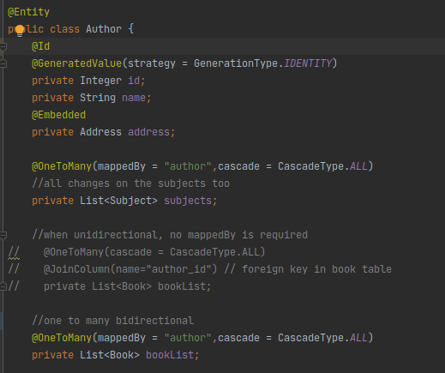

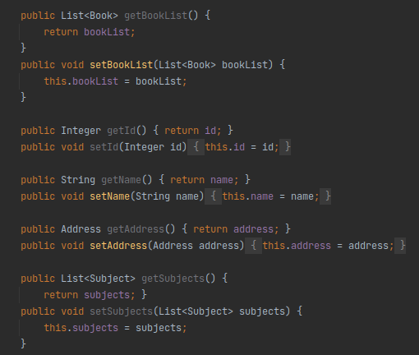

Book.java

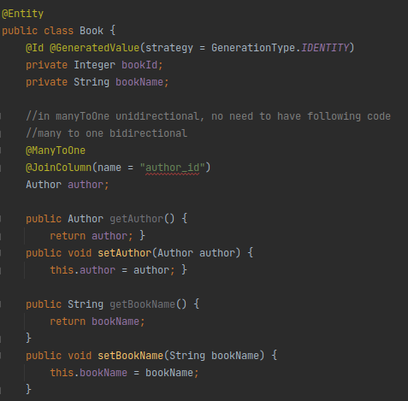

AuthorController.java

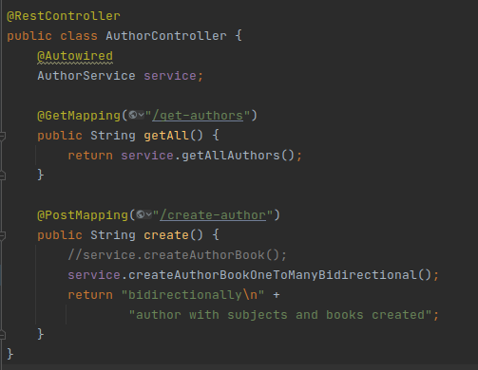

AuthorService.java

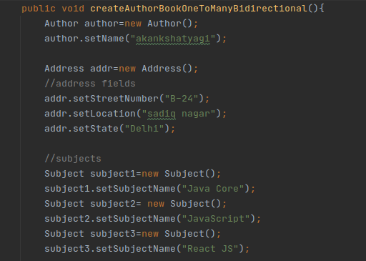

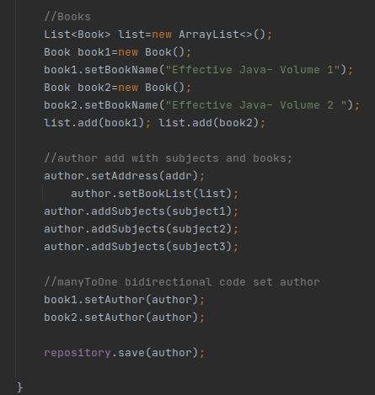

**Output:**

Data inserted:

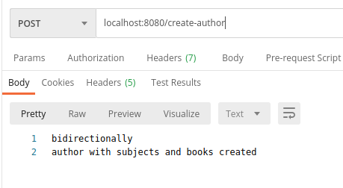

Tables:





Select * from various tables.

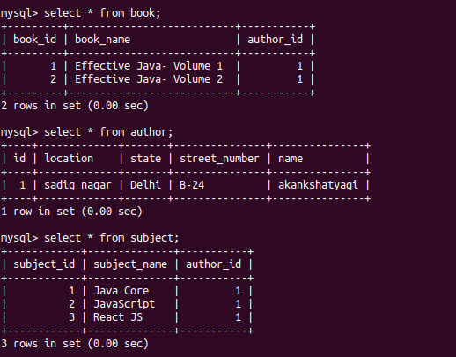

**8.Implement Many to Many Mapping between Author and Book.**

Author.java

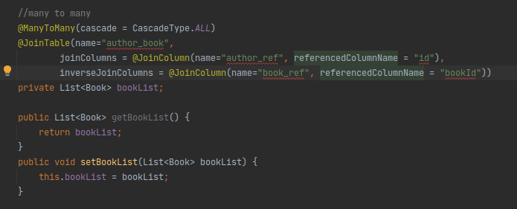

Book.java

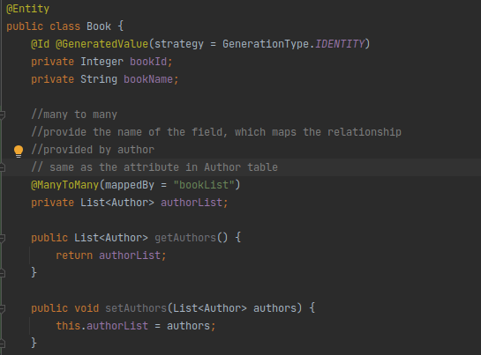

AuthorController.java

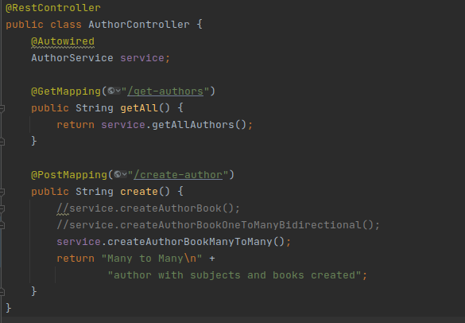

AuthorService.java

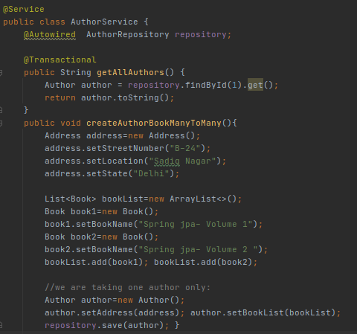

**Output:** 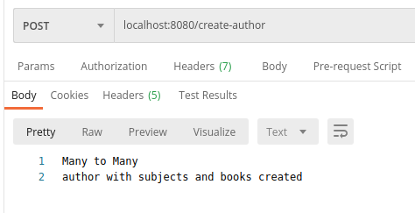

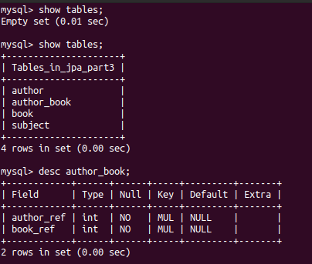

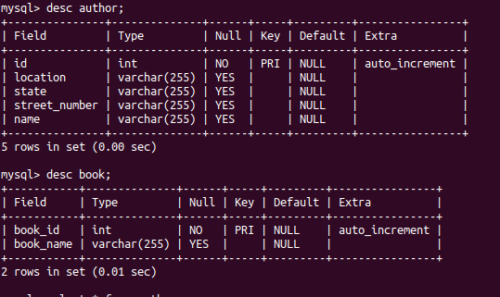

**Select statements:**

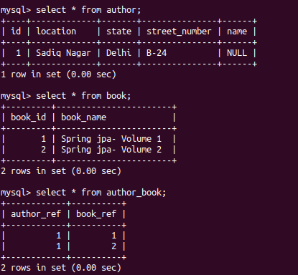

**9. Which method on the session object can be used to remove an object from the cache?**

**First Level Cache:**

**AuthorService.java**

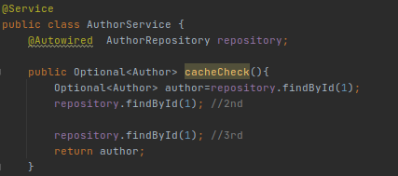

**AuthorController.java**

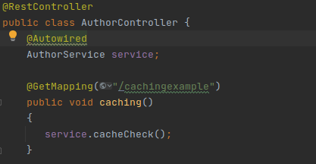

**Output:**

findById(1) is executed only once.



**→ evict()- to remove an object from the cache.**

AuthorService.java:

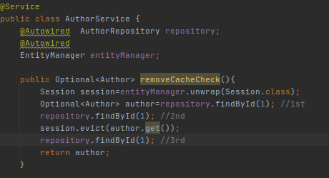

AuthorController.java

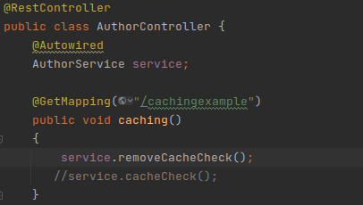

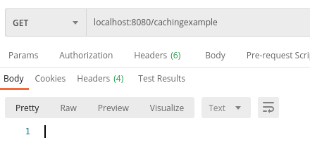

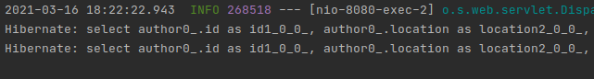

**10. What does @transactional annotation do?**

**BankAccount.java**

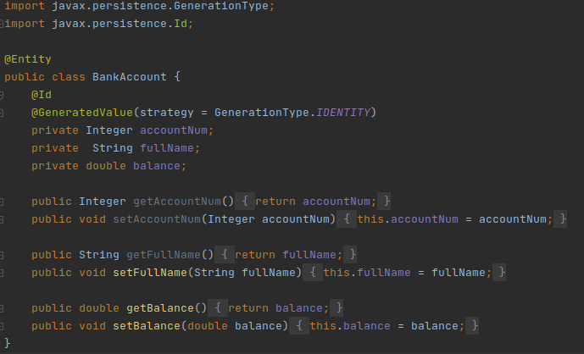

**BankService.java**

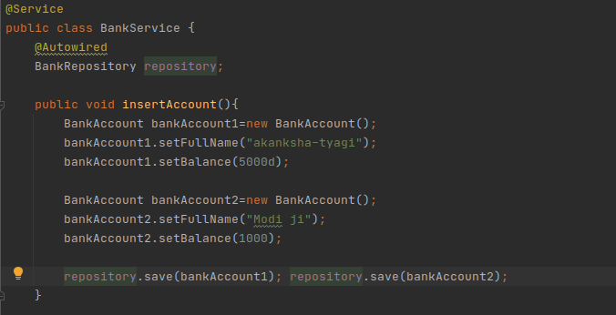

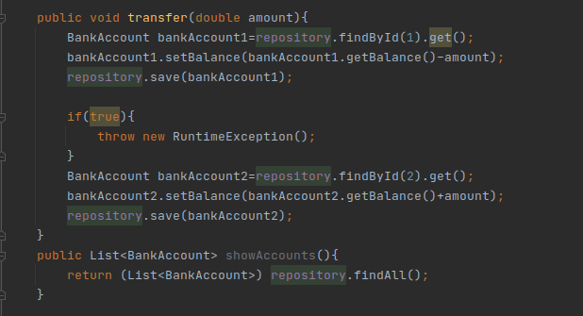

**BankController.java**

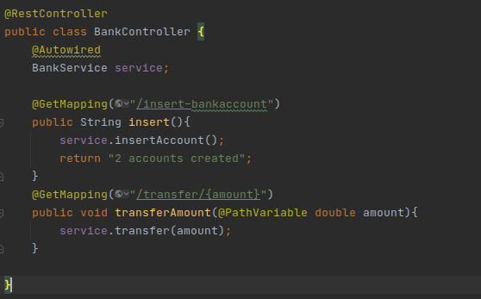

There is only one update statement on the console but there should be 2.

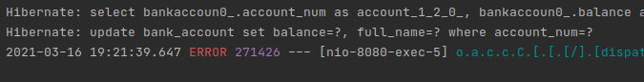

**Without Transactional**

**THE AMOUNT IS DEDUCTED FROM ONE ACCOUNT BUT NOT UPDATED IN ANOTHER ACCOUNT AS EXCEPTION IS THROWN IN BETWEEN.**

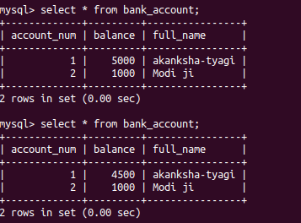

**With Transactional**

BankService.java

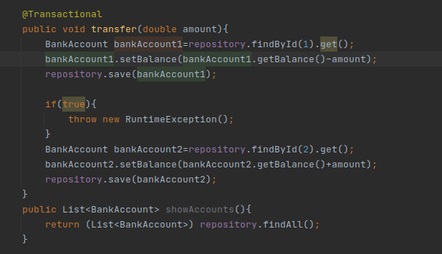

BankController.java

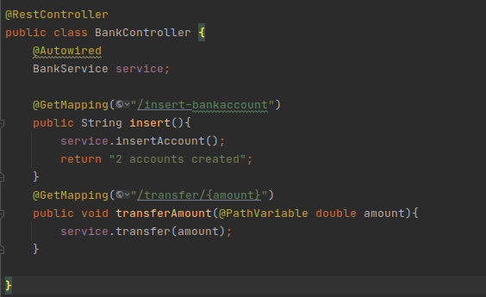

There is no update statement(atomicity concept)



**THE AMOUNT IS NOT DEDUCTED FROM ONE ACCOUNT AS EXCEPTION IS THROWN IN BETWEEN.**

